**PRACTICAL - 1**

**Table 1 - ITEMS:**

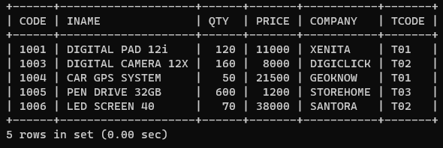

**Table 2 - TRADERS:**

For the above table, write queries for the following questions:

**Query 1:**

To display the details of all the items in the ascending order of item names (i.e. INAME).

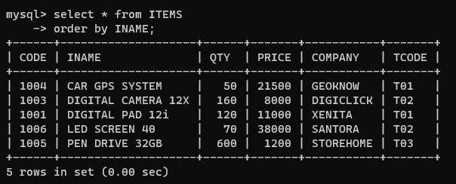

**Query 2:**

To display item name and price of all those items, whose price is in range of 10,000 and 22,000 (both values inclusive).

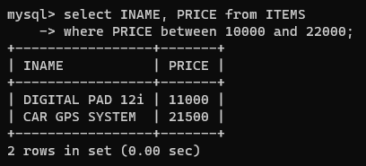

**Query 3:**

To display the number of items, which are traded by each trader. The expected output of this query should be:

T01     2

T02     2

T03     1

**Query 4:**

To display the price, item name and quantity (i.e. qty) of those items which have quantity more than 150.

**Query 5:**

To display the names of those traders, who are either from DELHI or from MUMBAI.

**PRACTICAL - 2**

**Table 1 - STUDENT:**

**Table 2 - DETAILS:**

For the above table, write queries for the following questions:

**Query 1:**

To show Fname, class and div of those students who are in class 8 in descending order of Tmarks.

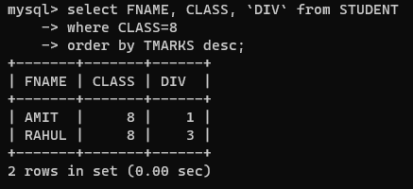

**Query 2:**

To count and display the number of students class wise.

**Query 3:**

To display details of students whose fname starts with 'T'.

**Query 4:**

To show Fname, class, address of those students who got more than 300 marks.

**Query 5:**

To display details of students with 2nd div in ascending order of their class.

**PRACTICAL - 3**

**Table - EXAM:**

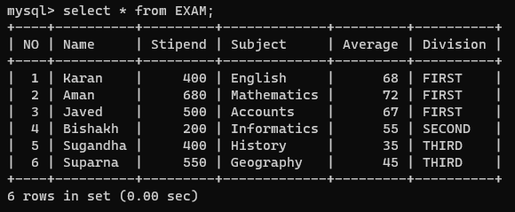

For the above table, write queries for the following questions:

**Query 1:**

To list the names of those students, who have obtained Division as FIRST in the ascending order of NAME.

**Query 2:**

To display a report listing NAME, SUBJECT, and annual stipend received assuming that the stipend column has monthly stipend.

**Query 3:**

To count the number of students, who have either accounts or informatics as subject.

**Query 4:**

To insert a new row in the table EXAM:

6, 'Mohan', 500, 'English', 73, 'Second'.

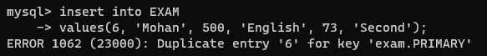

**Query 5:**

To show records of students who have 5 letters in name.

**PRACTICAL – 4**

**Table - FITNESS:**

For the above table, write queries for the following questions:

**Query 1:**

To display the names of all the products with price more than 20,000.

**Query 2:**

To display the names of all products by the manufacturer "Aone".

**Query 3:**

To change the price data of all the products by applying 25% discount reduction.

**Query 4:**

To add a new row for product with the details:

'P7', 'Vibro Exerciser', 28000, 'Aone'.

**Query 5:**

To add a new field Quantity in table.

